**WORLD OF WARCRAFT**

Game Design Document

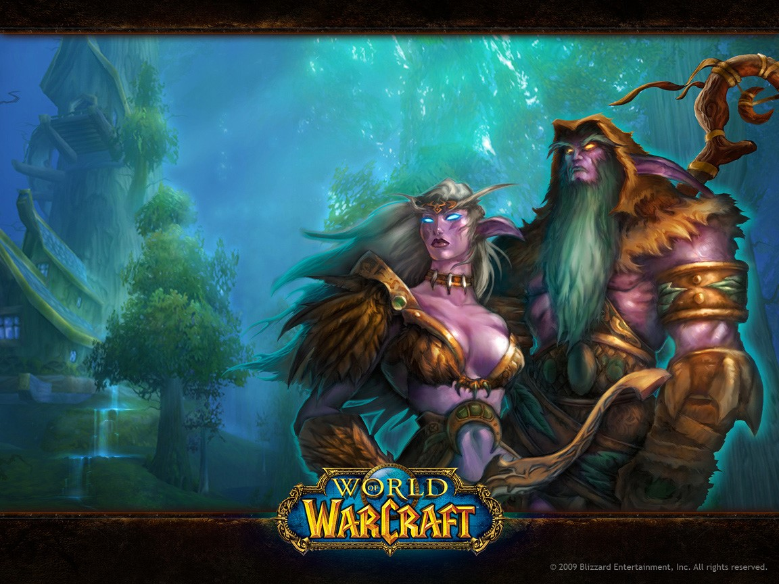

Prepared by: Florijan Henčel

Last Updated: March 2021.

|  |  |
| --- | --- |
| **GAME ANALYSIS** | **02** |
| **MISSION STATEMENT** | **02** |
| **GENRE** | **03** |
| **PLATFORMS** | **03** |
| **TARGET AUDIENCE** | **03** |
| **STORYLINE & CHARACTERS** | **04** |
| **GAMEPLAY** | **07** |
| **CONTROL SCHEME** | **15** |
| **USER INTERFACE** | **17** |
| **SCHEDULE & TASKS** | **18** |

**GAME ANALYSIS**

World of Warcraft, or WOW for short, is a 3D fantasy game set in the Warcraft universe. World of Warcraft is considered the "gold standard" of its genre worldwide, despite the fact that the game was released in 2004. It is still one of the most played games in the world. The game is full of fantastic music, balanced gameplay and excellent background and historical attachments.

**MISSION STATEMENT**

The game offers players a complete experience from start to finish with well-written quests, frequent fights, a huge world to explore, raids at the end of the game (end game) and player-to-player (PVP) fights in arenas and battlefields. The original game that we will write about here was released in 2004, but over time it received numerous sequels in which the maximum level of players increased from 60 to 70 and 80 up to 120. The game is also free for all new players up to level 20. Publishers and the developers also offer the Parental Controls option to give parents an insight into how much time their child spends and what everything is doing within the game.

**GENRE**

“Our Special Place” is a combination of the following genres:

* Massively multiplayer online role-playing game (MMORPG)
* Fantasy
* Entertainment
* Action game
* Virtual world
* Societal

**PLATFORMS**

The game is primarily built on a PC so the platforms are:

* Microsoft Windows
* MacOs

**TARGET AUDIENCE**

Originally, WOW was conceived as a game for experienced gamers. Mostly male population, without any special age limit. Today, 16 years later, politics has changed somewhat and the company considers money to be in the Asian market (one of the reasons Pandas, monks and oriental music were inserted in the 5th Expansion). There is almost no marketing for the western market, but 85% of marketing resources go to Asia, specifically to China.

**STORYLINE & CHARACTERS**

Every player in WoW has the potential to be unique compared to others. The game offers a variety of race / class / faction combinations. All players are divided into two factions Horde and Alliance. The hordes are divided into Orcs, Trolls, Undeads and Taurens, the Alliance is divided into Humans, Night Elfs, Dwarves and Gnoms. Races have their classes, and it is important to note that the combination of races and classes is limited. The races are warrior, hunter, paladin, shaman, druid, hunter, warlock, mage and priest. In later expansions new races were added, like the aforementioned Pandas choosing faction at level 20, the horde got Blood Elfs and Goblins, the Alliance got Drenai and Worgene. Classes like the aforementioned monks and Death Knight and Demon Hunter have also been added. At the start of the game, each player matches his character to play with, first choosing a faction, then a race and finally a class, but also a name, gender, skin color, hair, facial expression, and accessories such as a mustache, beard, earrings.

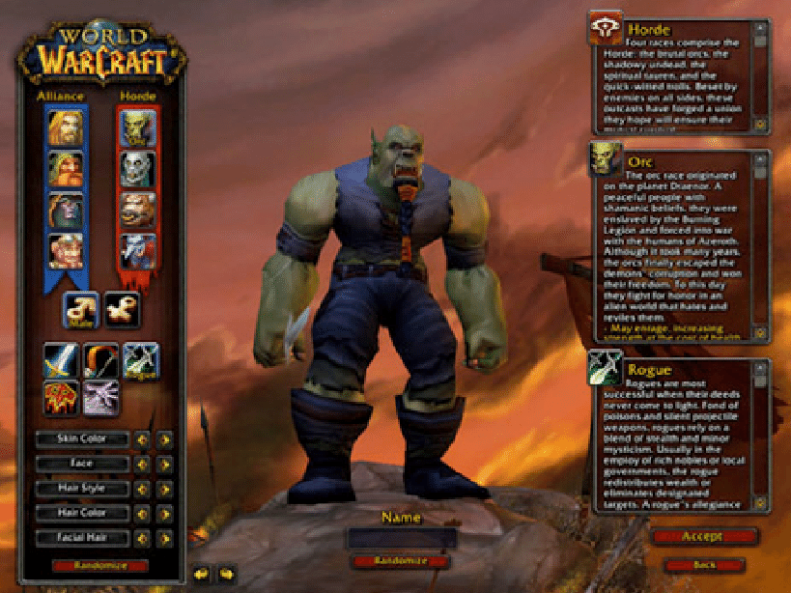

In the rest of the description, we will give preference to characters that are not played with, but are encountered in the game, the so-called NPC. There are really a lot of them in the game and WoW is known for having thousands of NPCs with which the player can talk, which give tasks and which are important for the story itself. We will now meet some of them who are considered the most important, because it is almost impossible to get close to the number of characters in the game itself.

|  |  |  |  |
| --- | --- | --- | --- |
| Character | Description | Characteristics | Misc. Info |
| **Warchief Thrall** | Thrall is the orc, the leader of the Hord, their commander chief (Warchief) at the beginning of the game. It is located in Orgrimar (the capital of orcs, trolls and the whole horde) | Thrall is a shaman. He governs the elements, he is an honest leader and he is valued by the entire Horde. | Trall je kao i svi ostali vođe, neprijateljski nastrojen prema suparničkoj fakciji i uvijek je level ?? što znači da je 2 levela veći od najvećeg igrača u grupi |
| **King Varian Wrynn** | Varian is human, the leader of the Alliance, and their king at the beginning of the game. It is located in Stormwind (the capital of humanity, but also of the entire alliance) | Varian is a warrior. He believes in the code of honor and muscle strength. Sometimes he can be selfish and find it difficult to listen to the advice of his co-workers. | Varian, is like all other leaders, he is friendly to his faction and offers several quests for lower levels to make it easier to get to know his city. |
| **Ragnaros** | Ragnaros is a fiery elemental found in Molten Cor. The first raid in which players are referred to level 60. In the original game he was so strong that it took a group of 40 players to beat him. | He was the first Boss to have over 1 million HP. According to legend, Ragnaros gathers strength to set fire to the entire Azeroth (the world in which the action of WoW takes place) | Ragnaros, like all the bosses in the raids, after the victory drops the items that are better than all the others who are in the rest of the game. The player must beat Ragnaros several times if he wants to have the best equipment. |
| **Kel Thuzad** | Kel Thuzad is the final boss at WoW. It is located in Naxramas. At the end of the raid, which is also a prison for all to send Azeroth. | Kel Thuzad was once a powerful human magician until his interest in black magic overtook him and he is one of the most credited for spreading the plague across Azeroth. | Kel Thuzad was the main villain in WoW but later returned in the 3rd Expansion and in 2 smaller dungeons which are a smaller version of raids for 5 players. |
| **Sylvanas Windrunner** | Sylvanas is the leader of the Undeads, they are located in the Undercity - the capital of the Undeads and is one of the most respected leaders in the Horde. | She used to be an elf, but she lost the fight and was forever turned into Forsaken, a sub-faction of the Undeads. | Sylvanas is a hunter and her strength lies in her arrows. Undeads traditionally cannot be a hunter, which makes her an exception in her race. |
| **Malfurion Stormrage** | Malfurion is the leader of the Night Elves and one of the smartest and oldest living beings. It is located in Darnassus, the capital of the Night Elves. | Malfurion is a druid, and its main power is to take the form of animals, such as bears, cats, seals, eagles, or even trees. | Malfurion is known in the WoW world for his wise sayings and composure, but also for key political victories for the Alliance. |
|  |  |  |  |

**GAMEPLAY**

**OVERVIEW OF GAMEPLAY**

World of Warcraft takes place in a 3D replica of World of Warcraft in which players participate through their characters. Each player starts from level 1 in the initial zone determined for each race, and with a system of quests and fights through dungeons, collects exp and moves to new zones where quests are harder, dungeons bigger, and opponents harder and more demanding.

**PLAYER EXPERIENCE**

Players are instructed to work together from the very first start of the game. Already after a few introductory quests, players are given tasks to kill an enema that is too strong for themselves and they need to cooperate with others. Also, the chat system is designed to move from the local level (chat with players near you) to regional (players on your continent) to global (players around the world) all the way to universal (players throughout the game (since in later expansions bring new worlds)). Such a system has its advantages and disadvantages, so a group of 5 friends who play together from the beginning will have a better Player Experience than a player who has just bought a game and starts exploring everything himself. This of course is not too much of a drawback because such a player will often learn many things on his own that he would not in the group.

**GAMEPLAY GUIDELINES**

From the very beginning of level 1, the player is told which way he should go in order to progress. But since this is an Open World game that allows the player to move where and how he wants, it's all in the player's hands how he will behave. The guidelines are extremely useful for new players and are extremely well made. The new player thus has the opportunity after completing the quests in the starting zone, to continue the quests in "Zone 2" or to go to his capital, travel by airship or train to another city and continue the quests there. When the player reaches the final 60 level, he is also offered the option to continue doing quests in order to earn extra gold instead of exp or go to dungeons and later to raids in the fight against bosses. There is also a third option, fighting with other PVP players that was not too elaborate in the original version, but later had its own guidance system through quests and special items that players would use exclusively in P The ultimate goal of each player is to reach the last level. Once a player reaches level 10, each subsequent level until the final is offered a selection of talents. With each new level, the player gets 1 talent point which he can invest in one of the three talent trees and thus personalize and change his character even more. The following is an example of what a talent tree warrior who chose the Fury specialization looks like. VP fights.

**GAME OBJECTIVES & REWARDS**

The ultimate goal of each player is to reach the last level. Once a player reaches level 10, each subsequent level until the final is offered a selection of talents. With each new level, the player gets 1 talent point which he can invest in one of the three talent trees and thus personalize and change his character even more. The following is an example of what a talent tree warrior who chose the Fury specialization looks like.

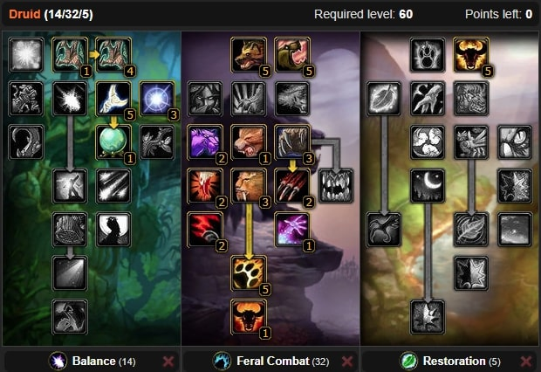

The ultimate goal of each player is to reach the last level. Once a player reaches level 10, each subsequent level until the final is offered a selection of talents. With each new level, the player gets 1 talent point that he can invest in one of the three talent trees and thus further personalize and change his character. The following is an example of what a talent tree warrior who chose the Fury specialization looks like.

**GAMEPLAY MECHANICS**

1. Epic Fight and Call - Epic Fight and Call refers to the feeling a player has when they believe they have made something big, even bigger than themselves and this is a specialty that WoW has managed to make first on a global scale. Everything is epic in WoW, from the first ignition of the game where the player watches beautiful footage of the zones and listens to epic music to the last quest and sense of importance in the WoW world
2. Development and success- This refers to the difficulties, making progress and developing your skills. Development and success are certainly the most recognizable part of WoW gameplay. Any player who has put so much effort and time into their character to get to the final level with him will continue to develop their character to make the final success at the end of the game the best possible.
3. Ownership and possession - What WoW has succeeded with its players is, to instill in them the idea that each of them owns everything they own and their character in the game. Items that get stronger as a player progresses from a plain lv 1 sword that looks generic all the way to an epic lv 60 sword that shines has an icon that every player cries out for. This is one of the main mechanics that the players stated kept them in the game and much much longer than they themselves expected.
4. Curiosity and unpredictability- The longing that a player feels for future events in the game is a major factor for players who do not like monotony and the same things. Many aspects of the game itself are made around unpredictability (RNG) and the element of chance is present from the very beginning. This was the main reason for playing players who preferred PVP because unpredictability in PVP fights is present in each round and each round is different compared to the previous one
5. Defeat and Loss- Unlike many other games, WOW has introduced a slightly different defeat mechanics. After the player was killed, he would turn into a ghost and show up at a nearby cemetery and be transferred to another realm. He should then walk to his corpse, which sometimes meant 5 to 10 minutes of walking. Dying thus did not mean defeat in the very sense of the word, but it would mean a waste of time that could have been used for something else. This mechanics would force the players to get better and better to avoid this unnecessary waste of time. The equipment would also be worn out with each dying and needs to be repaired which would also squeeze out unnecessary gold consumption.

**LEVEL DESIGN**

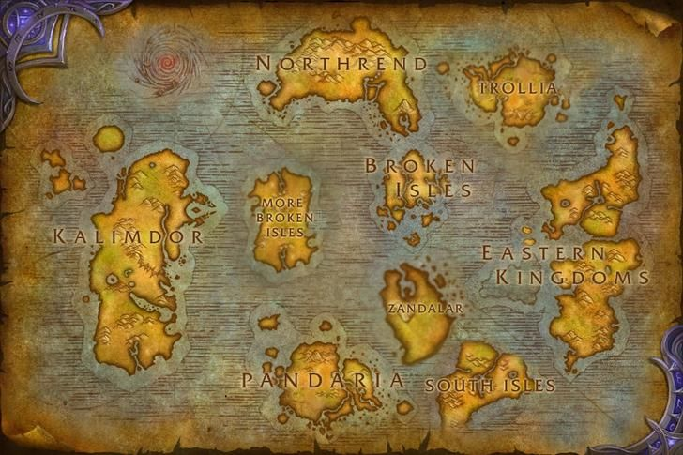

The world of WoW is huge it’s hard to talk about classic level design, not only because of the size of the world but also because of the Open Word environment. Originally the world was divided into Kalimdor and Eastern Kingdoms, later expansions added new continents but also new worlds to which players would travel through portals.

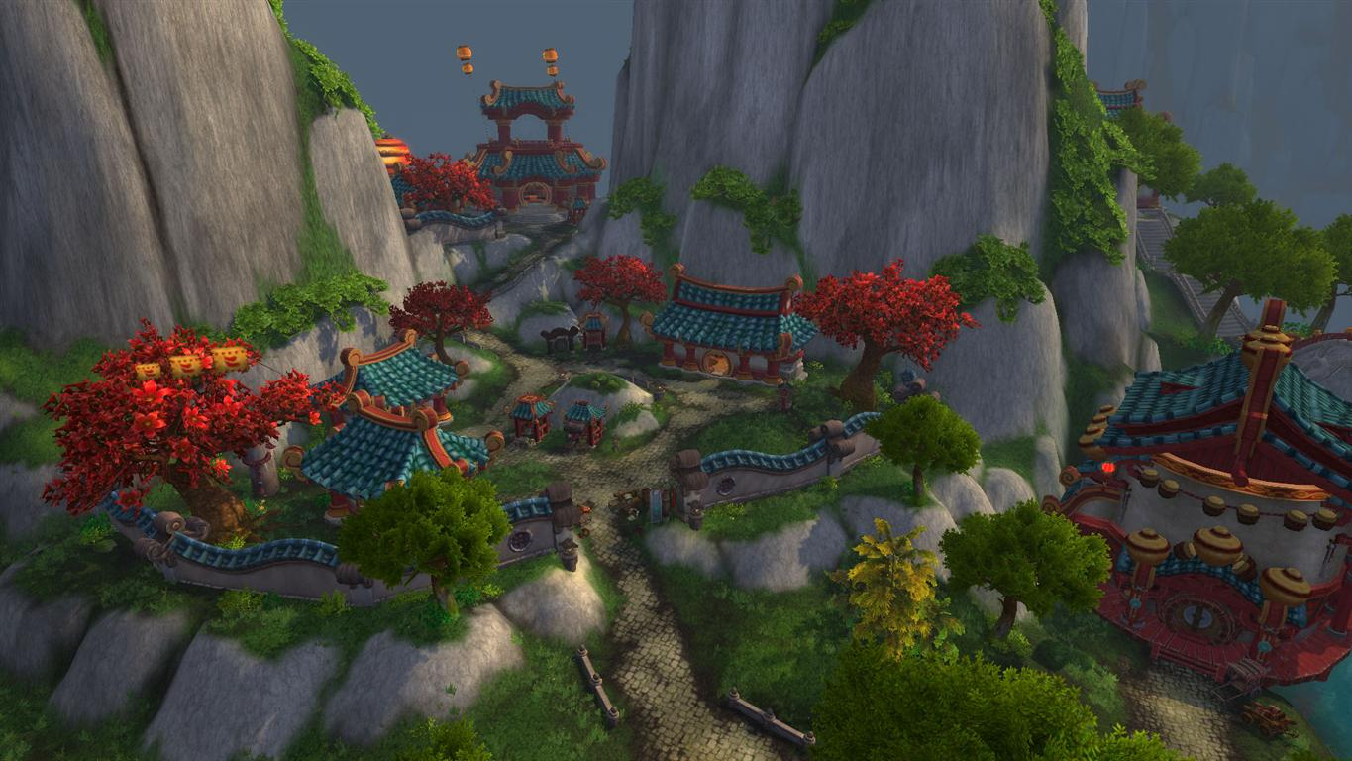

Each continent has several zones arranged by levels. The zones follow the logical order of the world. There are cold snow zones in the north, sandy hot zones in the south, and tropical rain / warm zones in the middle of the world.

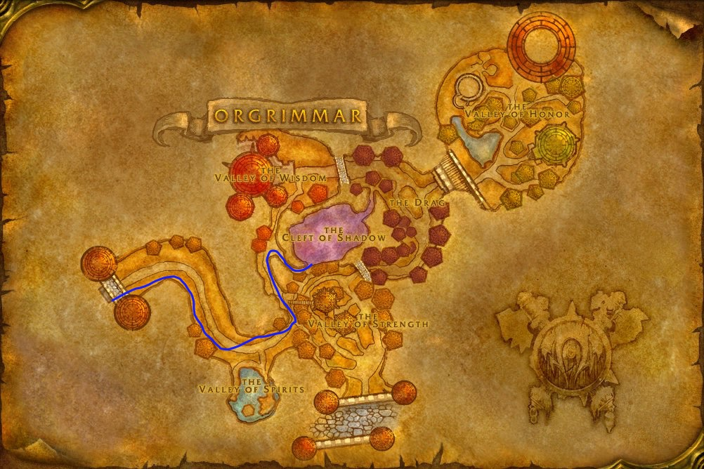

Dungeons are also an integral part of the game. Dungeons serve to give players a sense of playing in a group and win items that are in the range of their level, also by successfully completing the dungeons, players would be rewarded with a large number of XP. As a rule, they are intended for groups of up to 5 players.

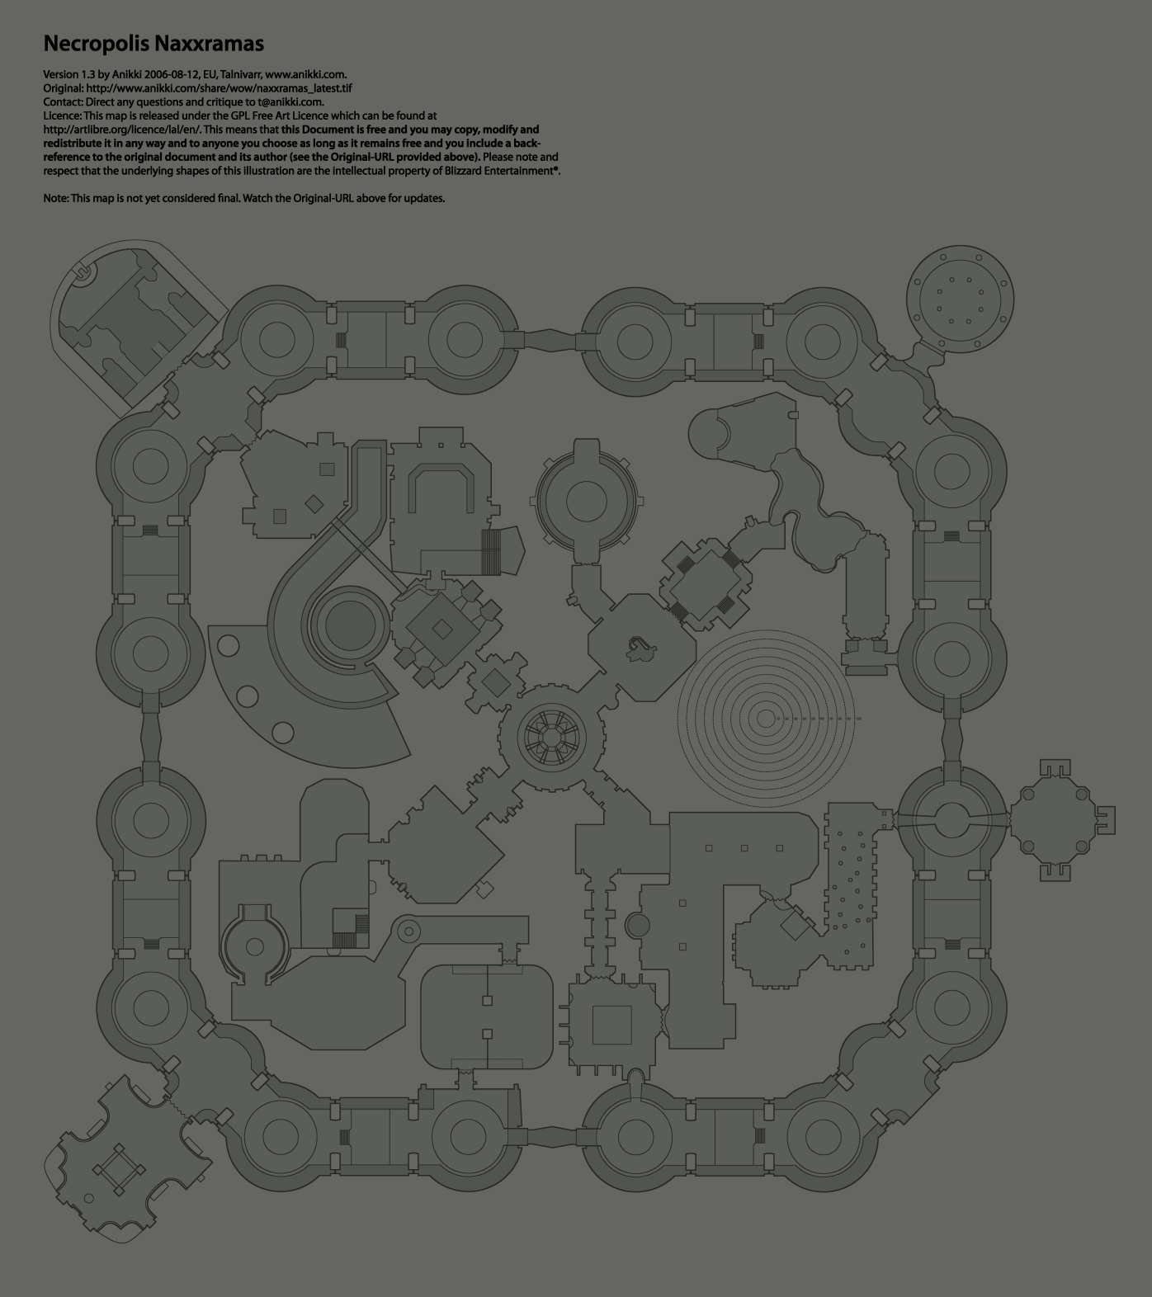

Raids are a large form of dungeon and involve between 10 and 40 people depending on the difficulty of the raid. The average raid lasts from 2 hours to 6 hours depending on the strength, experience and resourcefulness of the players. They are the final stage of the game and after the raid, the players are already at the final level and instead of exp they are rewarded with strong items and a larger amount of gold.

**CONTROL SCHEME**

The controls in Wow are completely changeable and can be customized to the needs of the players. The basics are not too different from the rest of the video games of a similar type. W A S D are the initial controls for movement that can also be performed by pressing the arrows. The Ability and spell that a player gets during the game is set to numbers 1 to 9 by default but can be changed because everything is adapted to change.

Also you can set ConsolePort add – on to play whit controllers. ConsolePort is a World of Warcraft add-on that supports PlayStation DualShock4 (DS4), Xbox 360 and Xbox One, as well as Steam controllers. It’s an add-on that doesn’t have the official support of the WoW development team over at Activision-Blizzard, but works just fine.

The setup is surprisingly simple and doesn’t require much more than the ConsolePort add-on, one of the aforementioned controller options, WoWMapper, and the World of Warcraft game itself.

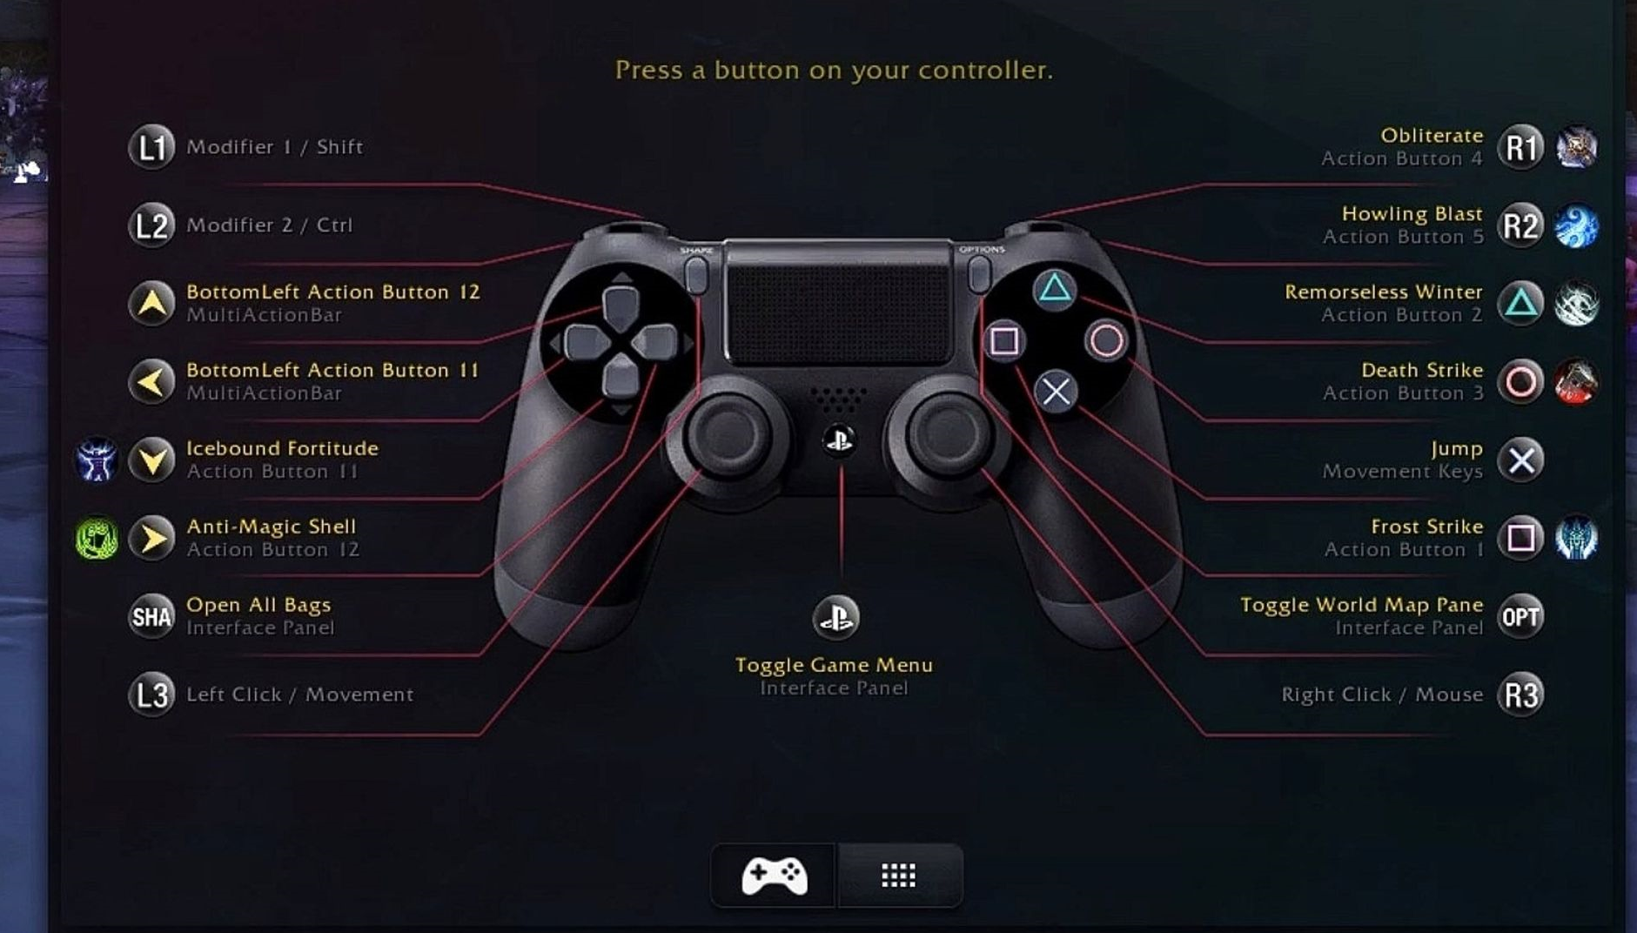

Playstation 4 controller control scheme

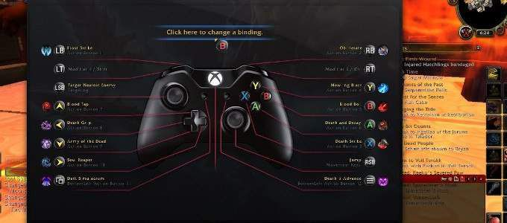

Xbox 360/ Xbox one controller control scheme

**Game Aesthetics & User Interface**

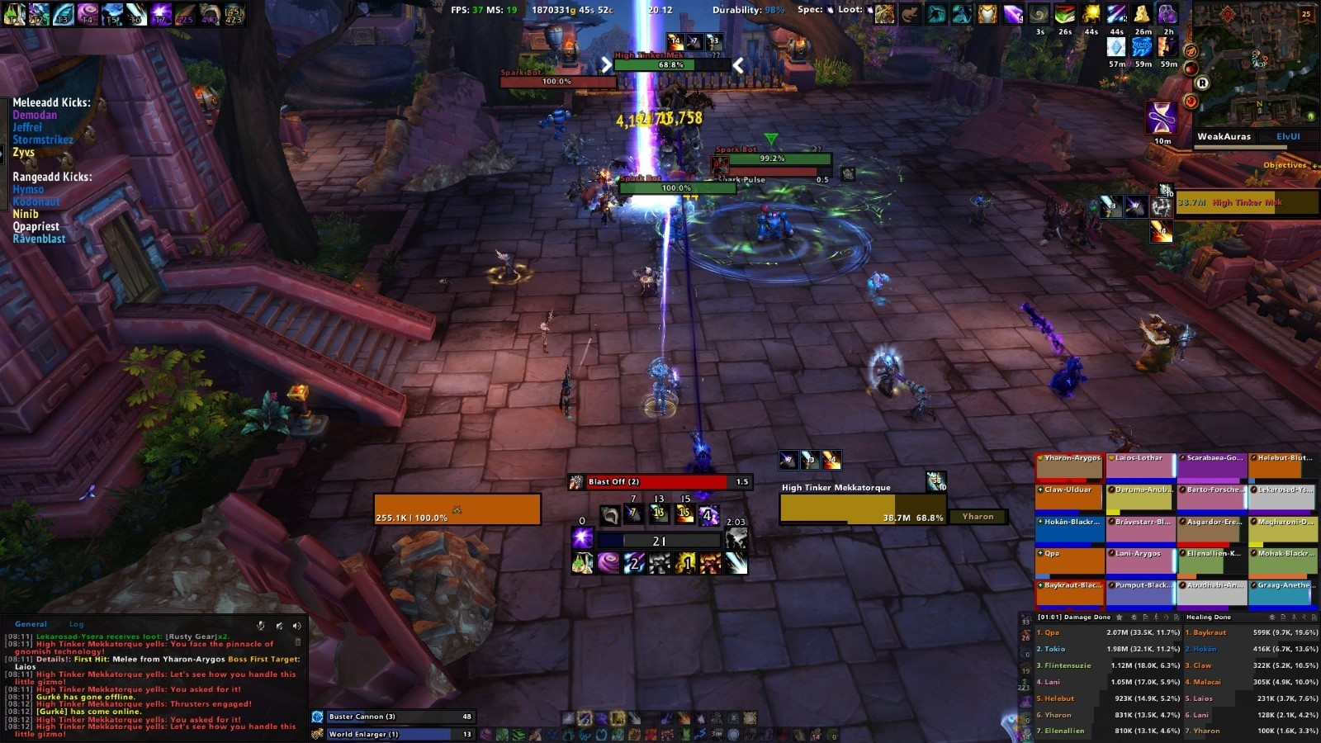

Much like the commands, the UI can be fully customized to the player’s requirements and desires. The basic UI is designed as an introduction for beginners and shows a list of spell / ability as well as the player's name, Hp, mana, chat, mini map, and a list of party members if the player does not play alone but in a group. In the upper right corner next to the mini map, buffs (positive effects on the player) and debuffs (negative effects on the player) are visible at all times.

**SCHEDULE & TASKS**

Since I could not find exactly the table of contents I will write what I found about it

### **Table of Contents**

* [**Pre-Release: 1998-2004**](https://www.usgamer.net/articles/how-world-of-warcraft-was-made-the-inside-story#preWoW)
* [**World of Warcraft: November 23, 2004**](https://www.usgamer.net/articles/how-world-of-warcraft-was-made-the-inside-story#WoW)
* [**The Burning Crusade: January 16, 2007**](https://www.usgamer.net/articles/how-world-of-warcraft-was-made-the-inside-story#BurningCrusade)
* [**Wrath of the Lich King Pre-Release: 2007-2008**](https://www.usgamer.net/articles/how-world-of-warcraft-was-made-the-inside-story#preWrath)
* [**Wrath of the Lich King: November 13, 2008**](https://www.usgamer.net/articles/how-world-of-warcraft-was-made-the-inside-story#Wrath)
* [**Cataclysm Pre-Release: 2009-2010**](https://www.usgamer.net/articles/how-world-of-warcraft-was-made-the-inside-story#preCata)
* [**Cataclysm: December 7, 2010**](https://www.usgamer.net/articles/how-world-of-warcraft-was-made-the-inside-story#Cata)
* [**Mists of Pandaria Pre-Release: 2011-2012**](https://www.usgamer.net/articles/how-world-of-warcraft-was-made-the-inside-story#preMists)
* [**Warlords of Draenor: November 13, 2014**](https://www.usgamer.net/articles/how-world-of-warcraft-was-made-the-inside-story#Warlords)
* [**Legion: August 30, 2016**](https://www.usgamer.net/articles/how-world-of-warcraft-was-made-the-inside-story#Legion)
* [**Battle For Azeroth: August 14, 2018**](https://www.usgamer.net/articles/how-world-of-warcraft-was-made-the-inside-story#BFA)

## **Pre-Release: 1998-2004**

While the in-game story of World of Warcraft springs from characters and storylines established in Warcraft 3: Reign of Chaos, many don't realize that the games shared a development timeline. Warcraft 3 was officially announced by Blizzard Entertainment at the European Computer Trade Show in September 1999, launching in July 2002. World of Warcraft was actually revealed at the same show in 2001, launching in November 2004.

They didn't just share development time at Blizzard's offices. They also shared some staff, like lead designer Rob Pardo, who worked on both projects.

Members of the Blizzard Entertainment crew were already avid MMO fans, as 1997's Ultima Online and 1999's Everquest were fairly popular when it came to PC players. It was decided that the team of the defunct project would be moved to Blizzard's own shot at an MMO. The concept was championed by Allen Adham, hailed by fellow Blizzard Entertainment co-founders Mike Morhaime and Frank Pearce as "the genesis of Blizzard." Adham would take charge on the team that would develop the game that would eventually be known as World of Warcraft.

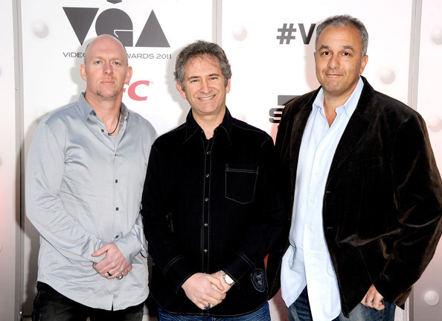

Blizzard Entertainment founders Frank Pearce, Mike Morhaime, and Allen Adham

Many of the early concepts and mechanics of World of Warcraft were drawn from the games that preceded it, like Everquest. The team was engaging with Everquest as fans, but also as game designers, wondering where the experience could be tweaked and improved. Everquest's death system forced players to trek back to their corpses, many times without weapons, to pick up their armor and items; meanwhile World of Warcraft implemented a different system where you were an invincible ghost and could pay a penalty to simply be resurrected at any graveyard. Everquest enemies would follow you until you reached a zone barrier, while WoW mobs were tethered to their starting location and would snap back if they got too far away.

Pardo was experiencing the community that formed at the higher levels of Everquest play; he was even running a rather large guild in Everquest while working on Warcraft 3 and World of Warcraft. He wanted to capture that feeling of community and camaraderie, but with a stronger sense of purpose—something that was missing in the rather open-ended Everquest.

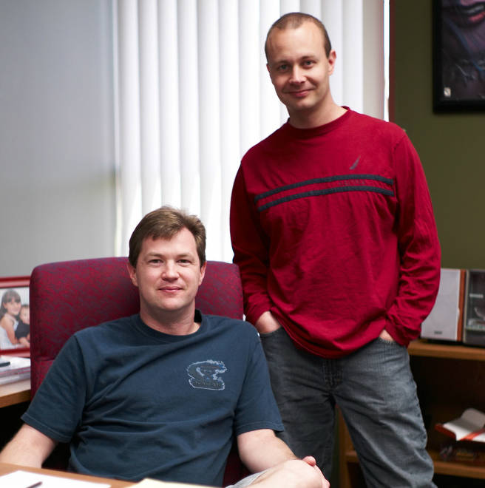

Former Blizzard Entertainment chief creative officer Rob Pardo (lead designer of World of Warcraft and The Burning Crusade) and former World of Warcraft lead designer Tom Chilton

The World of Warcraft team's idea were quests. Players would enter a zone, find the zone's quests, and these would act as training wheels and give you an idea of what you're supposed to be doing. At some point, your quest log would empty out and WoW would become more freeform, like Everquest.

"That was our on-paper design. But pretty early on, once we were doing team play tests, what we learned was the moment that you ran out of quests in your quest log, the game just felt broken and people didn't know what to do," says Pardo. "It was definitely this big moment where the team was like, 'Uh oh, I guess we have to do ten times as many quests as we thought we were going to do.' But I think it's one of those great moments that happen in game development, where once you find the nuggets that are really fun, you double down on it."

More quests meant that the WoW team needed to get bigger to compensate. So the team stocked up on new hires for quest designers. According to Pardo, one these new hires was associate game designer Jeff Kaplan, who you may also know as the game director for World of Warcraft: Wrath of the Lich King and a small game called Overwatch.